**Principles of Microeconomics**

**Group Project**

**Semester 1, 2020**

## Name: 葛欣憬、吕楠、宋文鑫、盛思腾、赵子涵

**Class: Class 2,Business Administration**

**Date of Submission: January 3, 2021**

1. **Introduction**

Explain the rationale for selecting the theme (product or service).

Briefly state the Microeconomics concepts that you will be discussing in this report.

The theme we chose revolves around **government behavior**, which is the regulator of the market economy, intervenes in the case of market failure or externalities, and helps the market to return to normal operation through good economic policies.

The concepts that we will discussing involves **price floor**,**market power of supply and demand**,**inflation**,**monopoly**, and **import tariff**.

## Discussion

**Newspaper Article #1**

### Article Title: National Development and Reform Commission: The minimum purchase price of rice will be raised in 2020, and the purchase quantity will be limited

Article URL: https://baijiahao.baidu.com/s?id=1659956714893160790&wfr=spider&for=pc

Microeconomics concept discussed: How the price floor affect the market outcome

(Write your analysis here, accompanied with suitable Microeconomics graphs, tables, computations etc)

As we all know, Farmers earn their living by farming, and grain is the main source of their income. Therefore, changes in the purchase price of grain affect the vital interests of everyone.

The report shows that China continues to implement the minimum purchase price policy in the main rice producing areas in 2020, which will effect the market outcome in a significant way.

1.From the very beginning ,I would like to find the reason why the price of rice is low in 2020.

(1)In terms of supply, due to the low purchase price of grain in previous years and the decreasing price level of rice in global marketplace, farmers have given up planting one after another, which affected the market and resulted in insufficient grain for enterprises who need a large sum of grain. It’s no doubt that this has greatly restricted the market mechanism and reduce the supply of grain. In the graph , we can see the supply curve moves from S1 to S2.

(2)In terms of demand, the outbreak of COVID-19 in the beginning of 2020 have forced people stuck at home, which contributed to shutdowns of restaurants and commercial areas. These places are the main source of customers that have a large demand of rice. Additionally, the government has been appealing to citizens for grain conservation to reduce the waste of food. These resulted in a slight decrease of the demand of grain. In the graph , what can be found is that the demand curve moves from D1 to D2.

All of the points mentioned above contributes to a new market equilibrium, point B. Because the reduction in supply is much more than that in demand, point B can represent a diminish in quantity and a increase in price. That can illustrate the reason for a low price of rice.

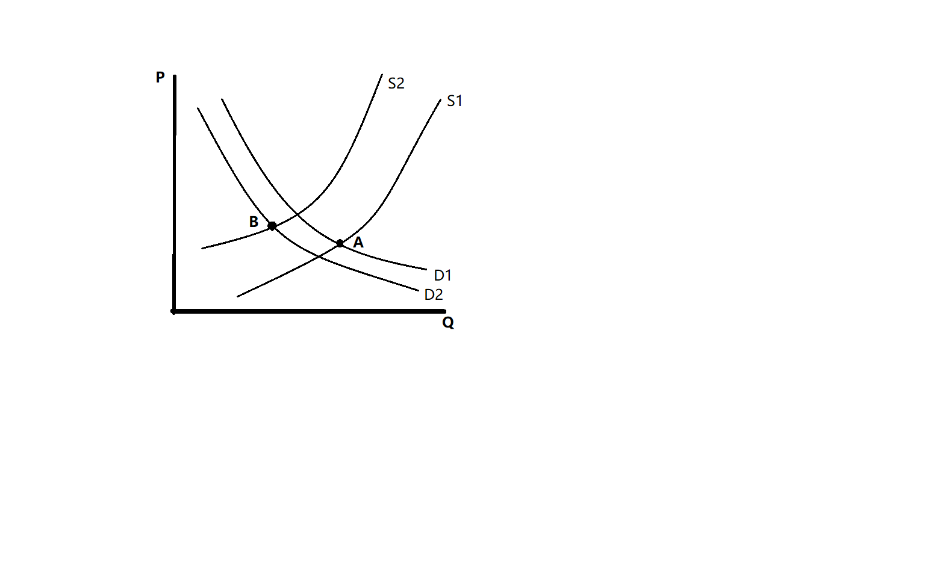

2.Then, as Mankiw mentioned, a binding price floor causes a surplus.

The price floor is a legal minimum on the price at which a good can be sold.

Just take the early mature grain for example. The government imposes a price floor of 1.21 RMB per kilo. Because the equilibrium price is below the floor, the price floor is a binding constraint on the market. The forces of supply and demand tend to move the price toward the equilibrium price, but when the market price hits the floor, it can fall no further. The market price equals the price floor.

At this floor, the quantity of grain supplied exceeds the quantity demanded. Because of this excess supply, some people who want to sell grain at the going price are unable to.

Thus, a binding price floor of grain causes a surplus.

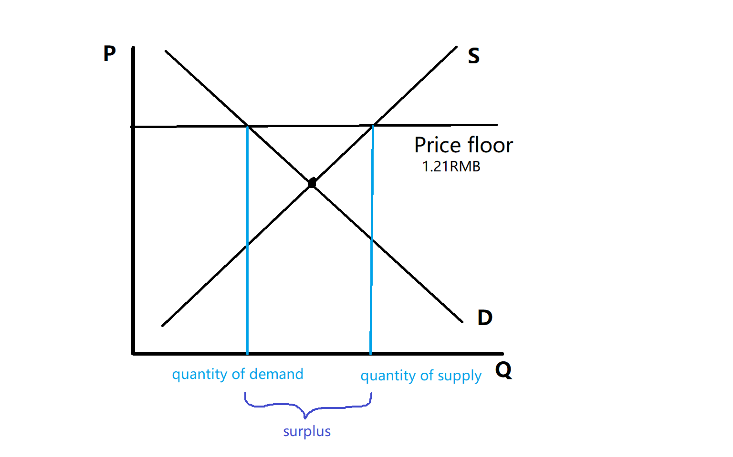

3.Last but not least, I want to predict the possible influence that the price floor of grain will have on the whole society as well as marketplace.

(1)It protects the interests of farmers, which helps farmers survive the sluggish market.

(2)It improves the structure of agriculture. With the price floor, farmers are likely to provide more product to improve the diversification of agriculture.

(3)It encourage farmers to produce grain of great quality. As we all know , people responds to incentives. The price floor is an incentive to farmers, which asks them to improve there product.

(4)It stimulate the vitality of market.

(5)The surplus of grain provides a perspective grain reserves for the whole country.

That’s all that I want to discuss, thank you.

## Newspaper Article #2

### Article Title: Soaring coal prices and coal queuing in mining areas: some traders earn 6 million yuan in a single transaction

Article URL: http://www.cctv-cmpany.video/chengshi/67870.html

Microeconomics concept discussed: Market power of supply and demand

(Write your analysis here, accompanied with suitable Microeconomics graphs, tables, computations etc)

As we all know, coal is a very important part in the process of maintaining the operation of a city, It can be used to generate electricity and heat... A city consumes a lot of coal every day, so coal price has become a part of the city economy.

1、Analysis of the reasons for the sudden increase in coal prices.

(1)The acceleration of economic recovery has driven coal consumption. For example, the development of industry is more and more rapid, which means that more coal needs to be consumed. The increasing demand for coal leads to the rise of coal price.

(2)The influence of seasonal factors. China is now in winter and needs more coal for heating. Secondly, affected by the cold season, the transportation of coal is more difficult, and the increase of transportation cost will also lead to the rise of coal price.

(3)The supply of coal from main producing areas is limited. The potential safety hazards in coal and oil mining are the urban safety issues that the government pays more attention to. In the second half of 2020, there were many coal mine accidents in China, which led to the upgrading of safety inspection, thus slowing down the coal mining. In addition, many government policies sometimes lead to the limitation of coal supply.

2、The influence of supply and demand on the market.

In 2008, the price of coal soared to 1060 yuan per ton, the highest price in nearly 20 years. Since 2012, the price of coal has been reduced, and no more than 1000 yuan per ton. This year, due to the strong demand for coal from steel, electric power, building materials and other industries, and the colder winter than in previous years, the price of coal is likely to rise to more than 1000 yuan per ton again.

Many cities have to buy high price coal because the coal reserves in power plants are below the warning line. For example, due to the closure of some coal mines in Shanxi Province, the reserves are too low, which indicates a decrease in supply, so we can only buy 600 yuan per ton of coal (the original 400 yuan per ton)

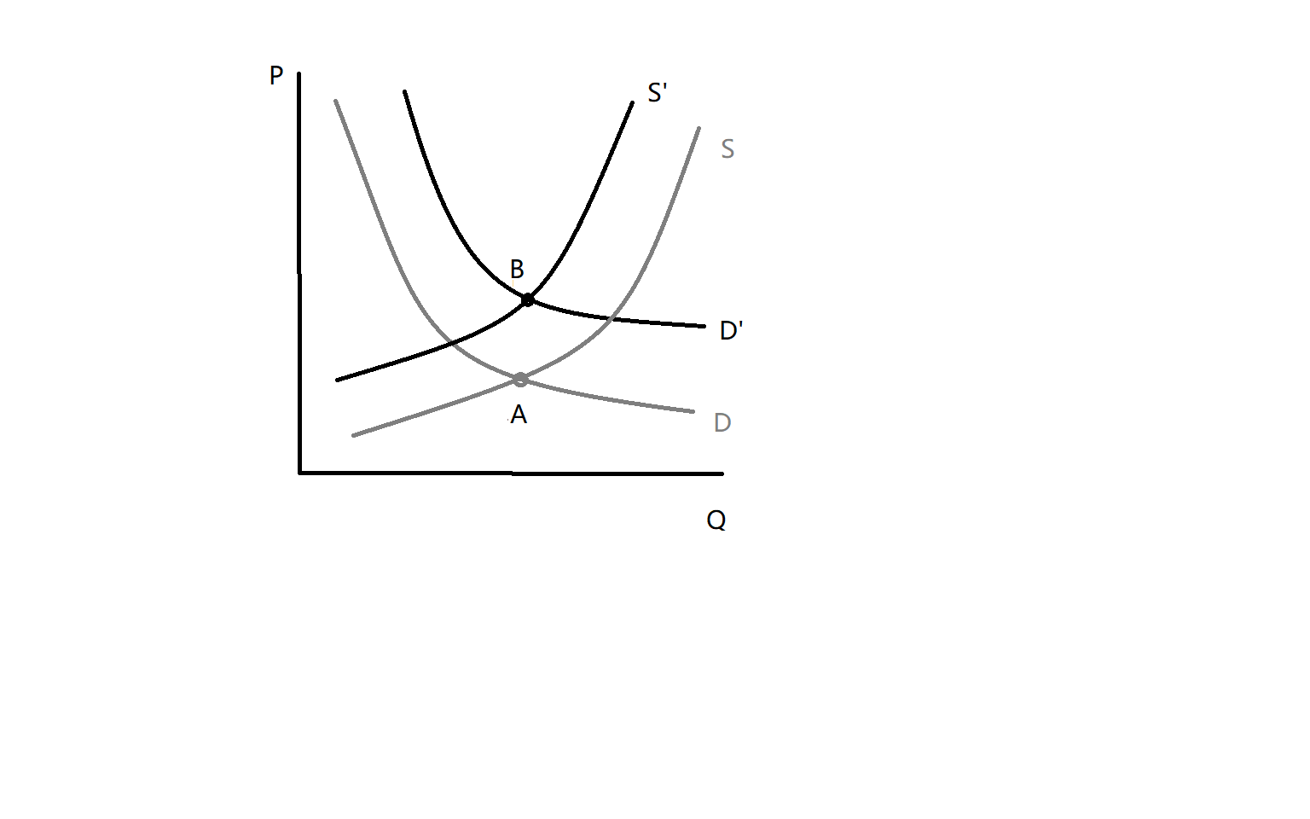

3、Impact of coal price explosion.

(1)Some traders are happy while others are sad. At first, the price of coal fluctuated, which made it difficult for them to start. The sudden price surge has made a lot of money for a small number of traders who seize the opportunity to enter the goods before the price rise. However, most of the traders have missed this opportunity and can only continue to trade as usual.

(2)The transportation business is booming. The sharp rise in coal prices has stimulated people's fear of price increase expectations and caused rush buying. The more coal they buy, the better the transportation business will be.

(3)As the industrial cost rises, the price of industrial products rises, but people's demand remains unchanged, and the rising price is finally paid by consumers.

(4)The excessive rise of coal price and the short supply of coal lead to the illegal mining in many places, which has potential safety hazards and damages to the environment.

These are my thoughts and discussions.

## Newspaper Article #3

### Article Title: Covid-19 could lead to the return of inflation—eventually

Article URL: https://mp.weixin.qq.com/s/b8zzGSBtMnOk5KT1Y63cfQ

Microeconomics concept discussed: Inflation

(Write your analysis here, accompanied with suitable Microeconomics graphs, tables, computations etc)

Inflation is the rise of the total price of the economy. In the 1970’s ,inflation is a common part of the economy. However,changes to policy and the structure of the global economy since have ushered in four decades of ever meeker growth in prices.

Before the outbreak of the COVID-19, the rise of the price seems so flat that there is a small possibility that the inflation will happen. But as what stated in the article, the inflation may return after the COVID-19.

1. What is inflation and what may cause the inflation happens.

The inflation refers to the rise of the total price of the economy. In most serious or sustained inflation, the main reason is the increase in the amount of money.

1. How the outbreak and development of the COVID-19 influence the price and the economy.

As the article refers, At present the amount of goods and services available for purchase is tumbling. Many service industries are shut down. The virus is playing havoc with the supply of some products. On April 12th Smithfield Foods, a meat-processing firm, said it would close a plant producing nearly 5% of American pork, after more than 200 workers fell ill; it has since shut down others. So if supply interruptions translate into shortages in shops, then higher prices could follow.Massive stimulus programmes are another potential source of inflation. Because the impact of the pandemic, the economy is in the downtown. Aim to stimulate the economy growth, governments are borrowing heavily to fund programs that support companies and workers and central Banks are injecting large amounts of new shipping money into the economy.As we can see in the following graph, the Fed's leverage increased during the outbreak of the COVID-19.

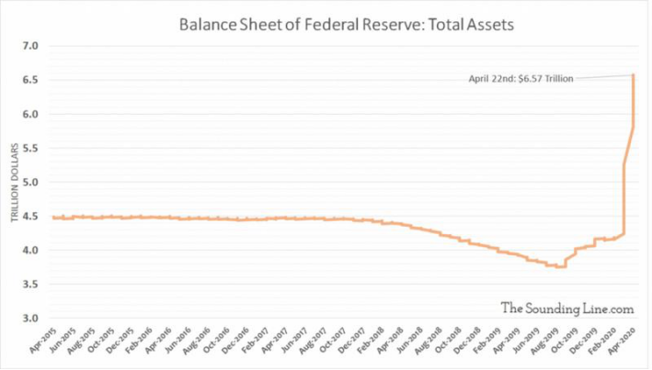

When the collapse of printing money and supply happens together, it may make people expect prices to soar.

1. What may be the probable time that the inflation happens.

The inflation effect is most likely to occur when the virus is truly defeated. The crisis could undermine the structural forces of demand, such as inequality, which concentrates on the rich in the frugal province. Attitudes towards policy formulation may have the same effect. The economic trauma of the early 21st century could prompt governments and central Banks to choose high economic growth and low unemployment.

That’s all my discussions, thank you.

## Newspaper Article #4

### Article Title: Taking Microsoft as an Example to Analyze Enterprise Monopoly

Article URL: http://text.news.sohu.com/28/68/sohu_subject143746828.shtml

Microeconomics concept discussed: Monopoly

(Write your analysis here, accompanied with suitable Microeconomics graphs, tables, computations etc)

Taking Microsoft as an Example to Analyze Enterprise Monopoly

1.Case Introduction

Microsoft Corporation, with a market value of 500 billion US dollars, is the largest listed company in the world. It was sued by the US Department of Justice and 19 States for violating the anti-monopoly law because it bundled the Internet browser with the operating system and prevented potential competitors from entering the market.

Although the browser dispute seems to be the focus of this case, the Microsoft monopoly case has a long history. Since 1993, the US Federal Trade Commission has used his privilege of "maintaining fair competition and protecting consumers' rights and interests" to start a very detailed investigation on Microsoft and began the process of collecting evidence step by step in a planned way.

On May 18, 1998, the US Department of Justice filed a lawsuit with the Federal District Court, and 19 States joined in. After the lawsuit went on for more than a year, on November 5, 1999, Judge Jackson made a preliminary ruling a few days ago: confirming Microsoft's market monopoly. The main basis of the ruling lies in four aspects:

First, there is evidence that Microsoft uses the popularity of its Windows software to illegally manipulate and monopolize the PC market and exclude other competitors;

Second, Microsoft tried to carve up the market at the meeting of computer peers. Netscape, Apple, Intel, etc. all put forward evidence to prove that they were threatened by Microsoft.

Third, the "browser" dispute. Microsoft has occupied a favorable sales channel by bundling the browser with the dominant operating system and software.

Fourth, make exclusive contracts with vendors, stipulating that vendors can only sell Microsoft products, otherwise they will be punished.

2.Reasons For Monopoly

If an enterprise is the sole seller of its products and there is no similar substitute for its products, then the enterprise is a monopoly enterprise.

The basic reason of monopoly is entry barrier, and monopoly enterprises can keep the position of sole seller in the market because other enterprises cannot enter and compete with it. There are generally three reasons for entry barriers. That is, monopoly resources, government regulation and production process. Based on this, we will analyze the causes of Microsoft monopoly.

Microsoft has developed from a small software company into an industrial monopoly giant, benefiting from continuous technological innovation. Because of the powerful function and convenient use of Microsoft Windows, other software

Businessmen basically design software based on Microsoft Windows. In this sense, Microsoft has mastered the source "resources" of software industry.

However, mastering technology is not enough to achieve monopoly. More importantly, Microsoft has won the recognition of consumers while stabilizing its position. And one by one, the operating platform based on Microsoft was established, which made Microsoft finally consolidate its monopoly position.

If Microsoft hadn't established a unified standard in the software industry, it would probably be as ups and downs in the huge software industry as Qian Qian Wanwan Small Company. It can be seen that the reasons for Microsoft's monopoly are resources and standards.

3.What effects did monopoly bring?

(1)Do bad to the consumers.

Now let’s look at the revenue a monopoly enterprise can get.

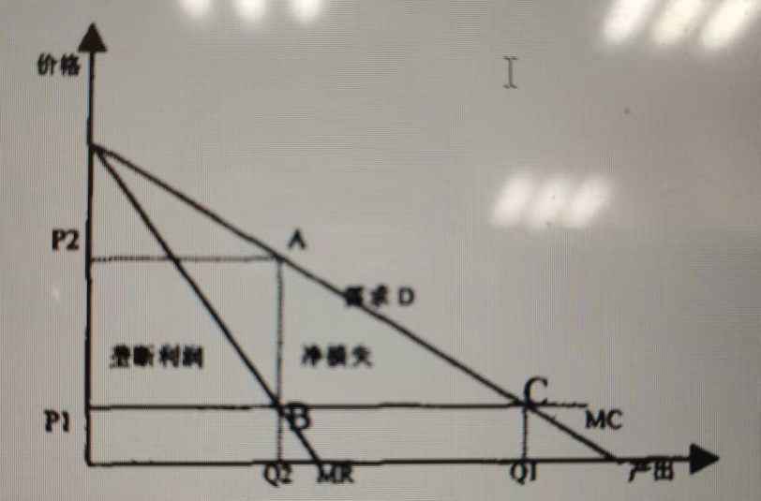

Because an enterprise has a monopoly position, it can produce according to the principle of maximizing profits. In order to maximize profits, monopoly producers set the output at the intersection of marginal cost curve and marginal revenue curve, and the price at the intersection of the vertical line of this point and the demand curve. The gap between the price and marginal cost of monopoly firms is the profit space of enterprises.

Compared with a perfectly competitive market, enterprises' production decreases and prices rise, which means that consumers have to pay higher prices for products, but only fewer consumers can get the products. Although this pricing method can bring larger profits to enterprises, it harms the interests of consumers and brings certain social welfare costs. The ABC part of the figure shows the social welfare cost of enterprises.

(2)Effective competition is disrupted.

Microsoft attempts to make its IE browser occupy a monopoly position in the browser market through bundling; Microsoft's bundling itself constitutes a "tie-in". When the whole market is only controlled by one or several enterprises, the whole industry is slow due to lack of competition. When there is no reference or lack of reference, the industry is slow to update its technology due to monopoly, which hinders the development of the industry, disrupting social order and damaging social fairness.

(3)Resources are underutilized.

In such an industry, Microsoft has few competitors. According to the long-term equilibrium conditions of the market, MR=AR=AC=MC, the manufacturer maintains the production equilibrium with the lowest average cost, and thus the production resources are fully utilized. However, in the long-term equilibrium under monopoly conditions, the equilibrium output determined by the intersection of MR curve and MC curve, when the marginal cost is lower than the average cost, the production at this time is not balanced under the lowest average cost, thus the resources are not fully utilized. Therefore, in a long-term bad situation, Microsoft's market will produce a lot of waste of resources.

4.Solutions to this case and their effects.

According to the ruling by Washington court, Microsoft will be divided into two independent companies, one specializing in computer operating system, and the other operating other businesses that Microsoft currently operates besides operating system, including Office series applications, IE browser, and so on.

However,in fact,it’s not an excellent solution.

After such division, consumers now have to deal with two monopolies, which will charge more than a single monopolist. Why? Both sides of the monopoly will demand more profits. One raises the price without considering the needs of the other, and the other will follow suit.While a single monopoly would take the interdependence of the two into account, thus keeping prices in balance.

Economist N. Gregory Mankin believes that the government's proposal to split Microsoft will create two companies that produce complementary products, operating systems and application systems. Microsoft used to keep Windows low because it stimulated sales of computers and their applications. Similarly, it keeps applications at low prices because doing so increases the demand for operating systems. But once the company is spun off, each component will have an incentive to raise prices. The Ministry of Justice claims that the two companies will eventually develop new products and compete with each other. This result is hardly guaranteed.

So,what’s the better solution to this problem?

The government should strengthen supervision and formulate or perfect anti-monopoly laws. Regulate the relationship between enterprises by regulating monopoly or restricting competition to maintain market order. Through the combination of the tangible hand of the government and the intangible hand of the market, the market order of fair competition will be established.

Entrepreneurs should take into account the negative impact on the society when developing the economy and obtaining huge profits. They should produce with the attitude of benefiting others and benefiting themselves and improve the moral concept of social responsibility.

Today's consumers should also play their own role and exert pressure from the consumer side to push the monopoly enterprises to develop healthily and contribute to their own interests, market competition and social long-term development.

## Newspaper Article #5

### Article Title: Tariffs for imports to be lowered next year.

Article URL: chinadaily.com.cn

Microeconomics concept discussed:

(Write your analysis here, accompanied with suitable Microeconomics graphs, tables, computations etc)

1.Case introduction

China will reduce or cancel tariffs on certain imported goods and materials starting in 2021, according to the Ministry of Finance. The new interim tariff rates on imports, which will be lower than Most Favored Nation tariff rates, will apply to 883 kinds of goods as of Jan 1, including foods, medicines and information technology products, the Office of the Customs Tariff Commission of the State Council, which is based in the ministry, announced on Wednesday.

2.Microeconomics concept discussed:

Here, we use the tool of demand and supply to analyze government policies and efforts on import tariff.

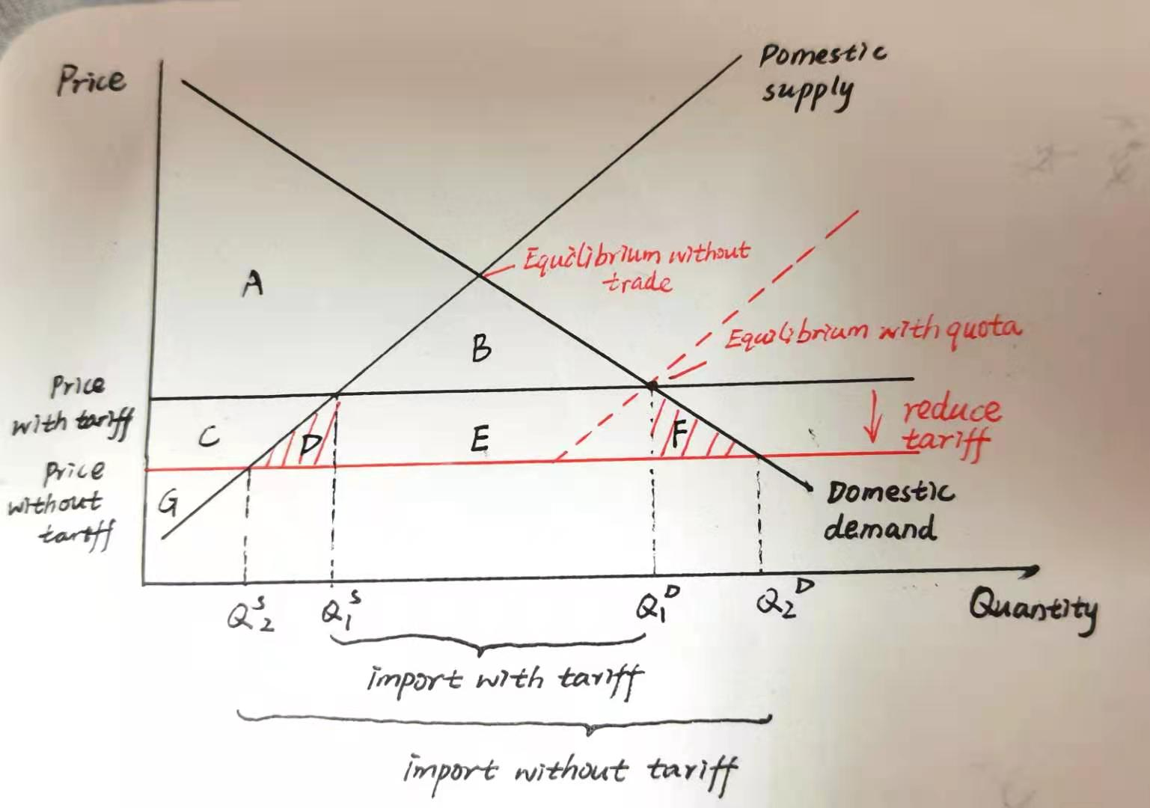

From the graph above , we can find that the tariff adjustment brings

1. lower prices (the former price minus tariff)

2. larger quantity of domestic demand (as shown in the figure by the demand point movement from Q1 to Q2). This is because people respond to incentives.

3. the deadweight loss decrease and the market reaches a new efficient market equilibrium ( shown as shaded part in red)

When the government imposes a tariff, the domestic price exceeds the world price by the amount of the tariff. Consumer surplus is area A + B. Producer surplus is area C +G. Government revenue, which is the size of the tariff multiplied by the quantity of after-tariff imports, is the area E. Thus, total surplus with the tariff is area A + B + C + E+ G.

Then the government cancelled the tariff , the domestic price equals the world price. Consumer surplus, the area between the demand curve and the world price, is area A + B+ C+ D + E + F. Producer surplus, the area between the supply curve and the world price, is area G. Government revenue equals zero. Total surplus, the sum of consumer surplus, producer surplus, and government revenue, is area A+ B + C+ D +E+ F + G. We find that total surplus in the market increases by the area D+F.

3.Analysis of the benefits of government actions:

Demand and supply

Consumption is expected to become a major driving force for China's economic growth in 2021 with more supportive policies in place. The tariff adjustment is meant to meet the growing demand in the domestic market, boost the domestic market.

Further reducing import tariffs will reduce the cost of import and stimulate the potential of imports , which will have a positive impact on both ends of demand and supply. Since 2019, China has seen sharp price fluctuations in markets such as pork and fruit ,which is not only bad for consumers but also has a negative effect on producers’ production expectations . The tariff reduction is conducive to expanding supply, easing the supply shortage of some commodities in the short run ,and calming down the large price fluctuations in these areas .

Market efficiency

In the absence of any tax, the equilibrium of supply and demand maximizes the total surplus of buyers and sellers in a market. It lowers the price buyers pay and raises the price sellers receive, giving buyers an incentive to consume more and sellers an incentive to produce more. As buyers and sellers respond to these incentives, the size of the market grows to its optimum . Thus, it causes markets to allocate resources more efficiently.

Increased variety of goods.

Goods produced in different countries are not exactly the same.Tariffs on imported goods related to daily life, such as food, health care products , pharmaceuticals and daily chemicals, have been reduced, and the domestic market has become more abundant. This will open up the domestic market, bring more choices to domestic consumers, meet their demand for high quality products, and further improve people ‘s living standards.

Producer strategy

Many high-tech raw materials and semi-finished industrial products are included in the list, which will undoubtedly reduce production costs, in other word ,the variable cost of production is decreased.This can not only encourage domestic production , help domestic manufacturing enterprises , but also promote the development of new types of infrastructure construction and high-technology products.

Increased competition.

A company shielded from foreign competitors is more likely to have market power, which in turn gives it the ability to raise prices above competitive levels. Opening up trade fosters competition and gives the invisible hand a better chance to work its magic. For the whole picture, it can strengthen the global competitive capacity of China's manufacturing industry.

4.Conclusion

Government can sometimes improve market outcomes. Government carries out policies to adjust the import tariff, which brings great effect to the market. Chinese government has the wisdom and power to make the economic world better off.

## Conclusion

Summarise the main findings of the above discussion.

The goal of your conclusion is not to introduce any new ideas, but to sum up what you have discussed earlier.

Just as what we learned before, governments can sometimes improve market outcomes.

1. In the rice market, Chinese government continues to implement the minimum purchase price policy in 2020, which will effect the market outcome significantly.
2. In the coal market, consumers faced a sudden increase in coal’s price so that the government should take some actions to control the price such as setting a price ceiling to protect the welfare of consumers and producers.
3. Governments should be prepared for a possible resurgence of inflation following the COVID-19 outbreak.
4. Facing the monopoly companies, the government should strengthen supervision and formulate or perfect anti-monopoly laws.
5. In the import market, Chinese government reduces or cancels tariffs on certain imported goods and materials to boost the domestic market and stimulate the economic growth.

In a word, Government plays an important role in economic activities. Appropriate government intervention can promote rational allocation of resources and safeguard the welfare of consumers and producers

## References:

Tan, A. (2018, May 16). Greenpeace cuts ties with Asia Pulp and Paper over allegations of deforestation. Retrieved from [https://www.straitstimes.com/singapore/environment/greenpeace-](https://www.straitstimes.com/singapore/environment/greenpeace-cuts-ties-with-asia-pulp-and-paper-over-allegations-of) [cuts-ties-with-asia-pulp-and-paper-over-allegations-of](https://www.straitstimes.com/singapore/environment/greenpeace-cuts-ties-with-asia-pulp-and-paper-over-allegations-of) (this is a sample)

---- END OF REPORT ----